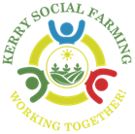

**Kerry Social Farming Newsletter**

Issue 4 August 2020

Welcome to our August Newsletter, we have lots of photos to share with you all and updates from around the county. More and more of our participants and host farmers are able to resume social farming in a safe and comfortable way. The Cahersiveen Community Programme based at Cúnamh House have been very busy and wanted to share their efforts with you all. The gang at Tigh an Oileáin have not rested at all during the last few months, they have lots more work and improvements for us all to see and hear about. Social farming has returned to Glencar and Beaufort so we’ve some photos from there as well. We hear from across North Kerry also where social farming is also coming back.

We would like to extend our sincere sympathy to host farmers Patricia and Anthony Kelliher on the recent death of Patricia’s mother Mrs. Kathleen Buckley. May she rest in Peace.

**Cahersiveen Community Programme**

After a few months break we are finally back at our day service here in Cahersiveen community programme. As you may know David and Ryan are two social farmining participants, here are some of the things we get up to here in the day service.

We have been kept very busy with outdoor work. David and Ryan have been busy working in our garden. We were lucky to have received new garden furtniture from our Organisation Kerry Parents and Friends Association. The furniture came flat packed and Ryan and David helped to put this together. We also upcycled some of our old seats and have more to do on our list.

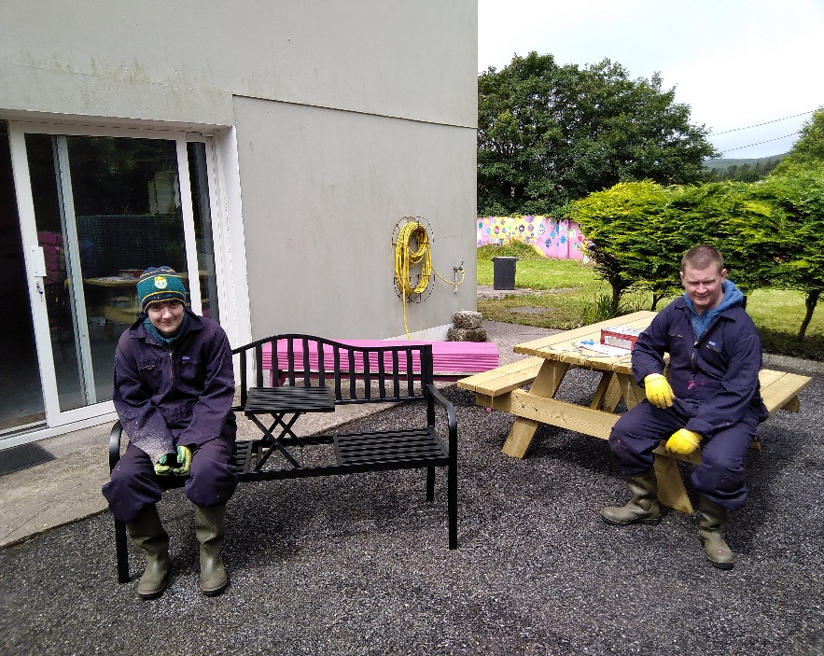

‘Taking a much needed break after putting the benches together’

Our bin area needed a lot of TLC so David helped to paint it up.

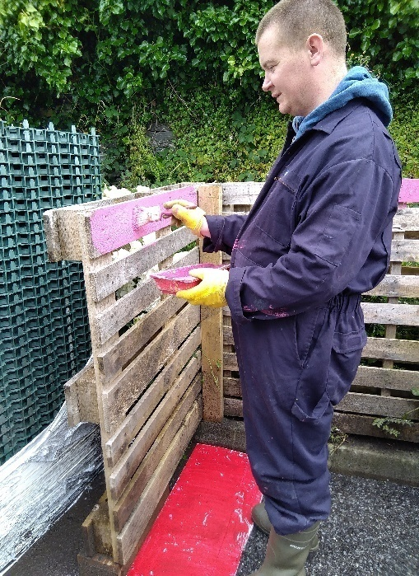

This is the beginning of our next project, we have a lot of work left to do, we will keep you posted on how we get on in the weeks to come. Below you can see David digging out the foundation and Ryan barrowing the grass away to our compost heap.

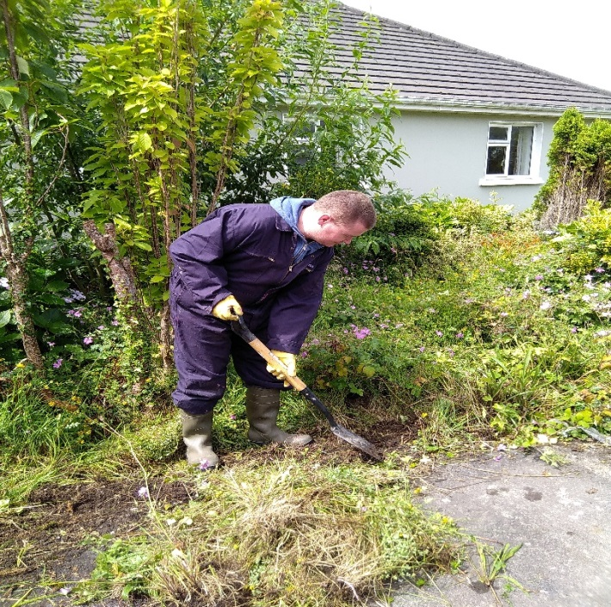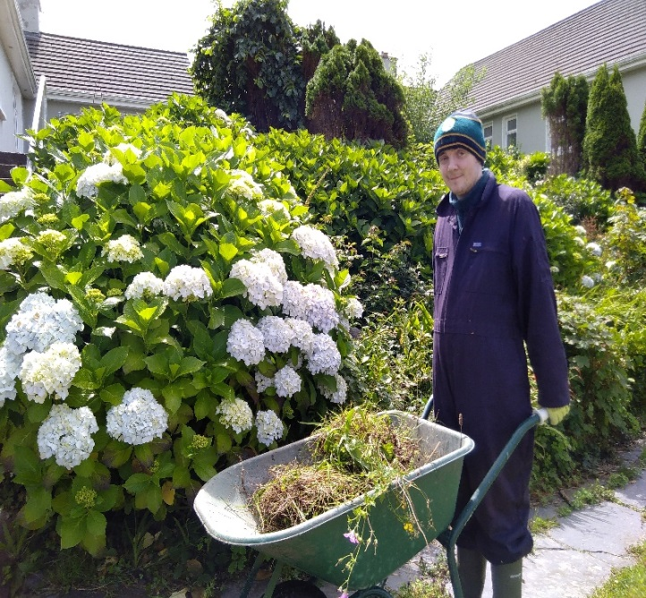

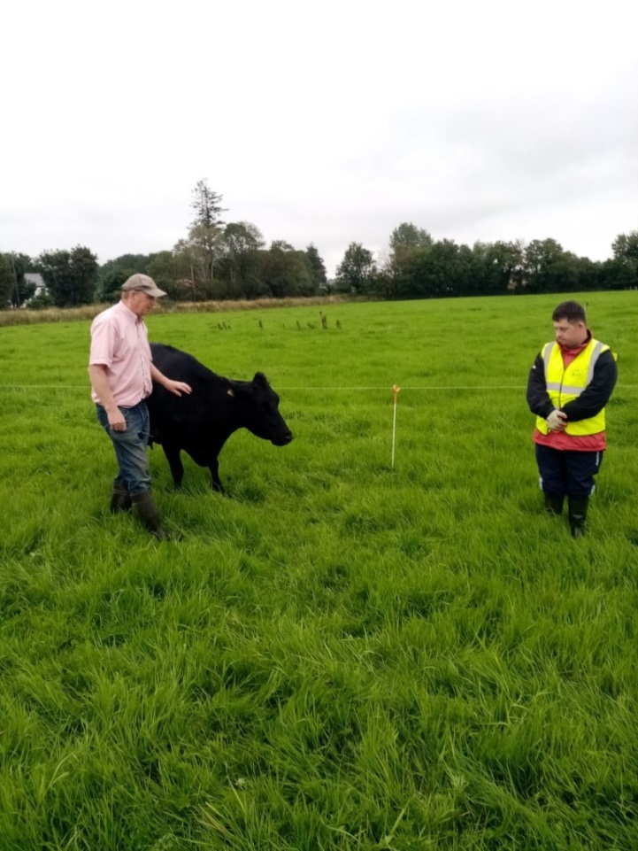**Stephen Brosnan, Claire Spillane & Brendan O Sullivan at George Kelly’s farm, Beaufort**

George and Stephen embracing a socially distanced social farming experience!

Stephen and Claire below helping to adjust the fence for the cows. Stephen and Claire attend the Kerry Parents and Friends Centre at the Old Monastery, Killarney.

Brendan is delighted to be back social farming and catching up with everyone and the farm after the time away from it. Brendan is below with the newest addition, a calf 3 days old.

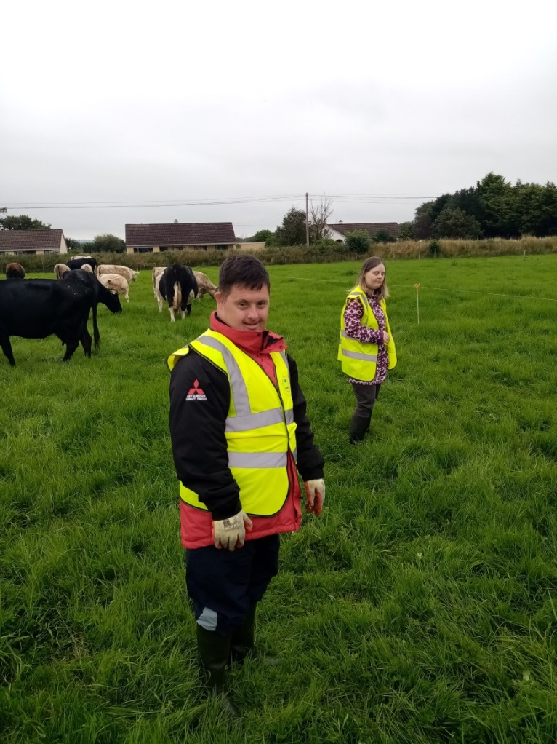 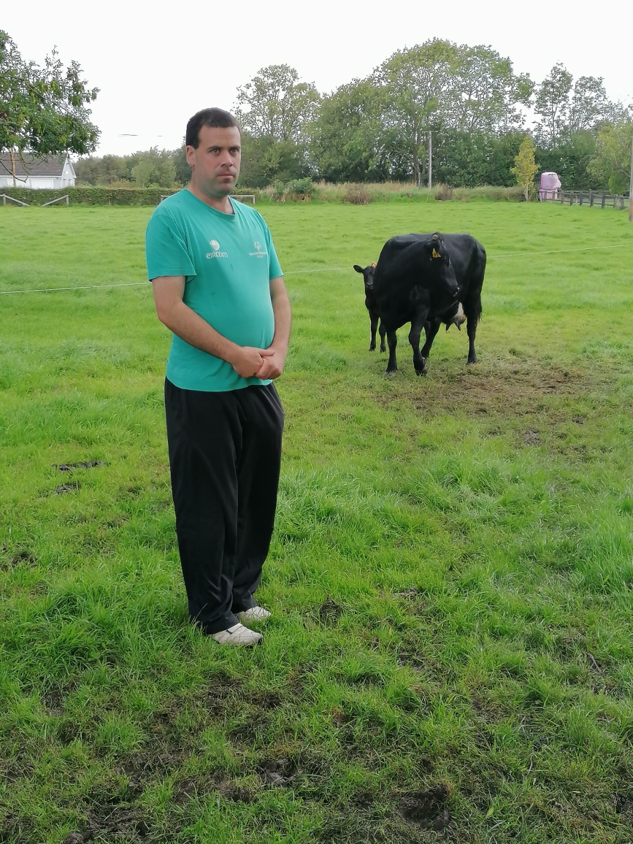

**Our two Breda O’Sullivans in Glencar**

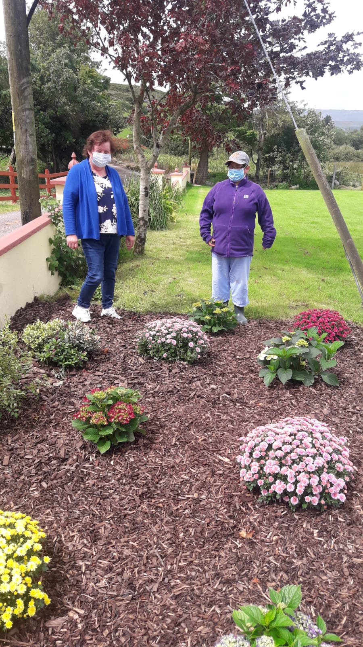28th July 2020

Breda had a break from social farming from 10th March to 21st July due to Covid-19, she returned to social farming 21st July this is her second week back she missed it so much.

Plenty of colour in the garden at O’Sullivan’s in Glencar.

As you can see from the pictures she loves feeding the lambs and dogs. The weather is good and she loves being out in the fresh air going for walks and gardening.

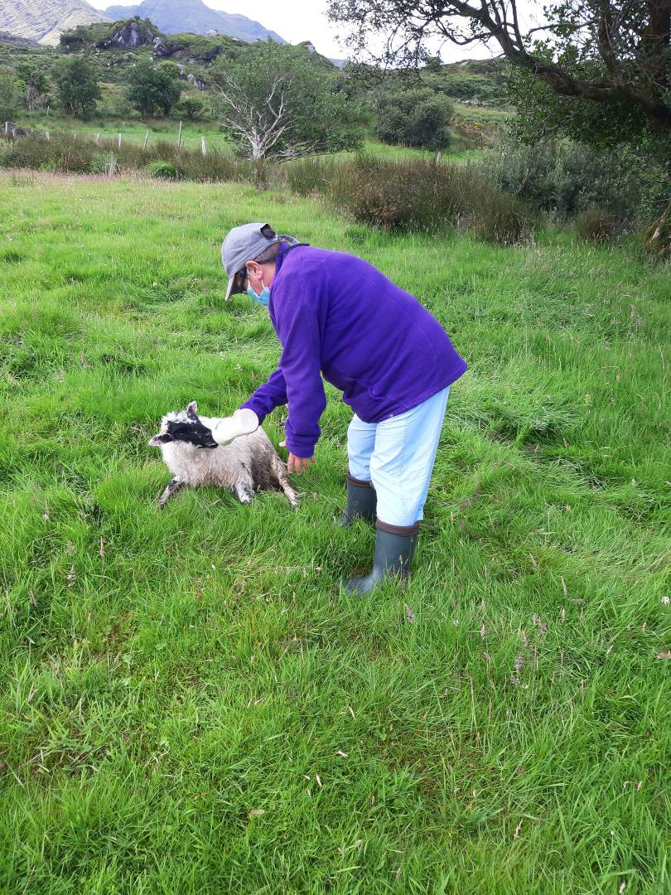

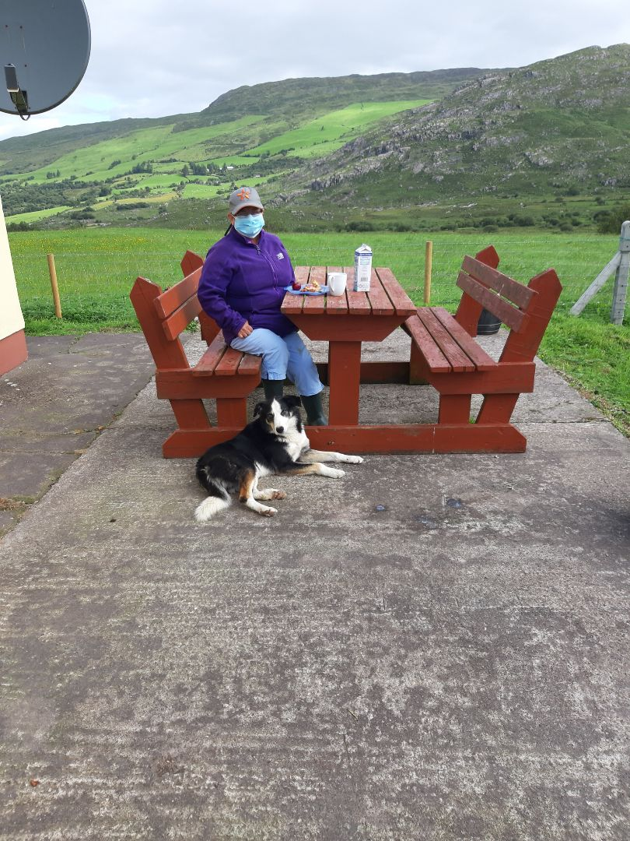

**Happy days as social farming resumes**

Hi all what a wet and windy July and August, here’s hoping for an Indian summer. Just a brief update on the return of social farming in North Kerry.  Over the past few weeks we had a number of Host farmers and participants return to Kerry Social Farming in both South and North Kerry.

This is welcome news for us all, we have all missed Social Farming over the past few months. And it's nice to have a return to our regular weekly routine. I would like to welcome back Maura and Tom from Maura’s Cottage flowers, Ian McGregor from Gortbrack Organic farm, Mary Healy, Ballyduff, Tom Sears from Scotia's Glen in Organic Farm which will start back soon also.

Also Antoinette and Bronagh which will be starting back with Lisa and I this Friday 28th of August.

We are all returning to social farming in very different times from before, we have new restrictions and guidelines to help us transition back through Covid-19.

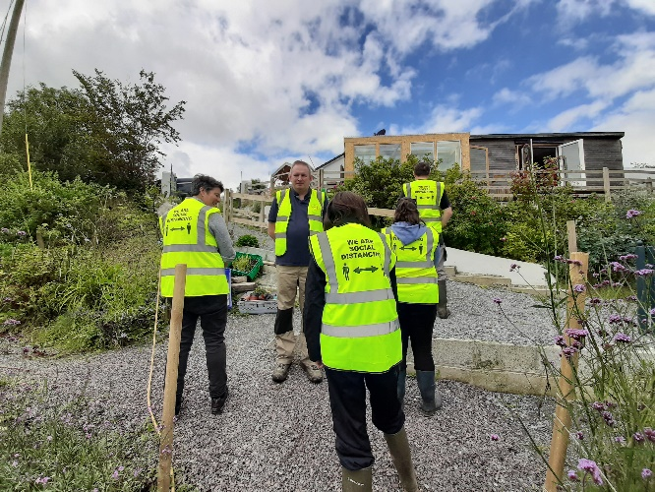This will take a little bit of adjustments for us all, but by working together we can do this, happy social farming days are here again enjoy the outdoor and stay safe.

Rena.

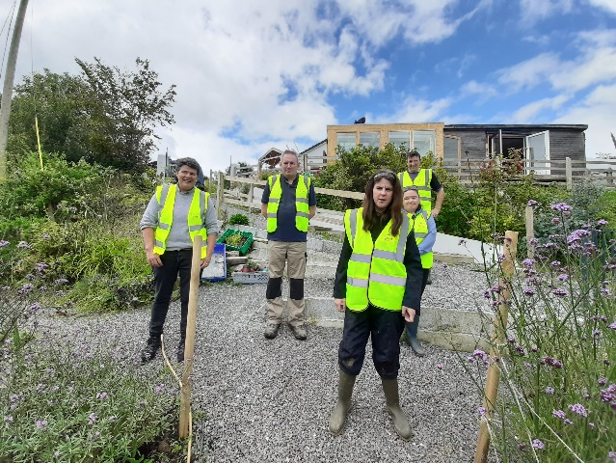

Participants Ciara and Vanessa with support worker Cormac are back at Maura’s Cottage Flowers in Ballyroe. Here they are with Tom Sheehy and facilitator Rena Blake. They’re all showing our new social distancing message on their high viz vests, helping us remember one of the key steps that will keep us safe.

**Tigh an Oileáin, Valentia Island**

Here at Tigh an Oileáin we have been working on some projects over the last two months.  We have even got some help from local volunteers to help us with the more laborious jobs.  Earl Leahy is extremely proud of all he has been doing with his peers here and wanted to send in a little bit about our projects to the Kerry Social Farming Newsletter.

We in Tigh an Oileáin started an outdoor bench project in June we had to use sanders and saws, and then paint it.  It is not finished yet but we are nearly there.  Our fields were very over grown. So some people from the local community came to help us cut it.  We used pikes and rakes and I worked very hard all day getting the grass ready for the tractor and trailer. I felt very well helping the boys. The other lads here are doing great work too.  Patrick is doing lots of painting on the bench and so is Alan.  Joe and Diarmuid are helping out too. I miss going to social farming with Ger and Tim O Sullivan. I hope to go back farming soon l have lots of projects to keep me busy at Tigh an Oileáin. We are building a pizza oven and a crazy golf area.

See you all soon,

from

Earl Leahy

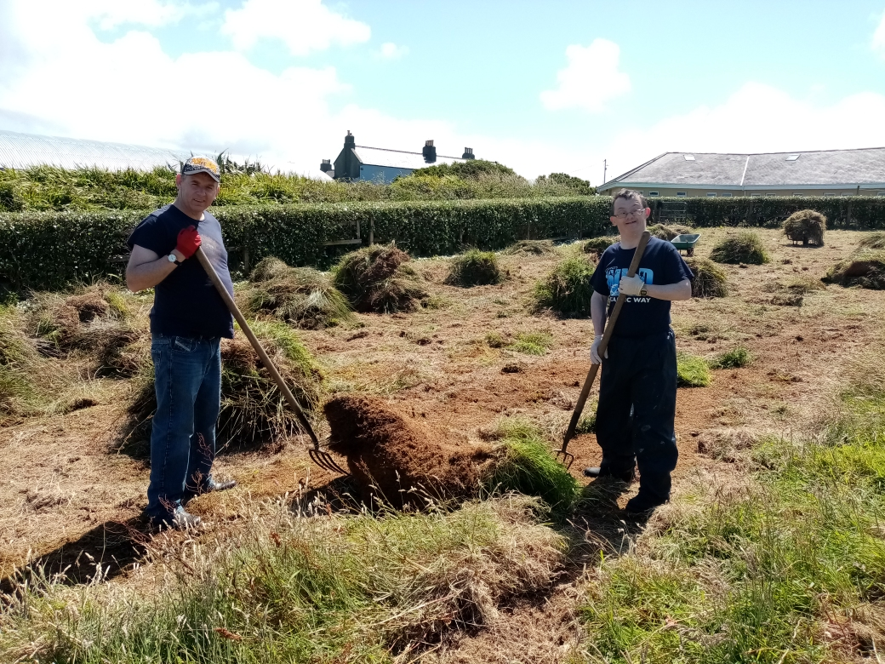

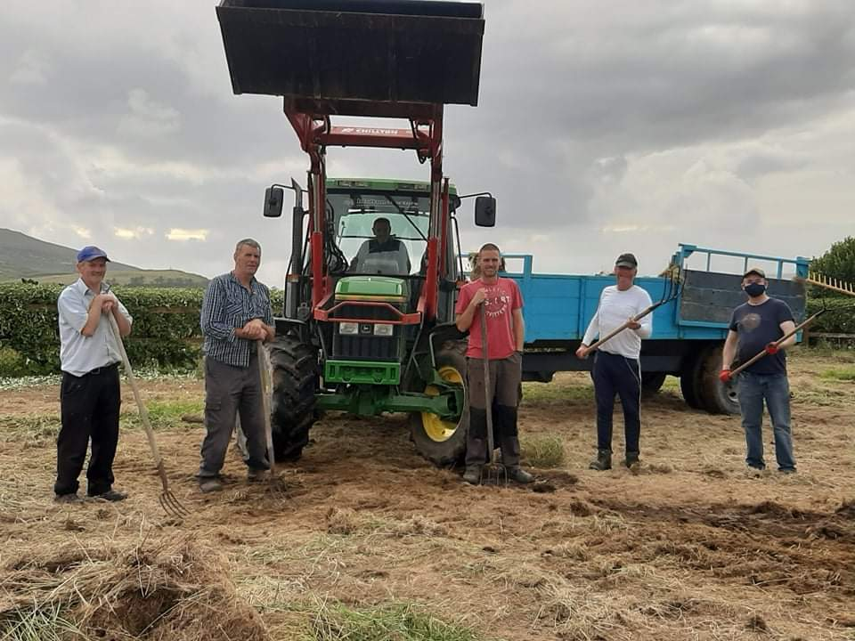

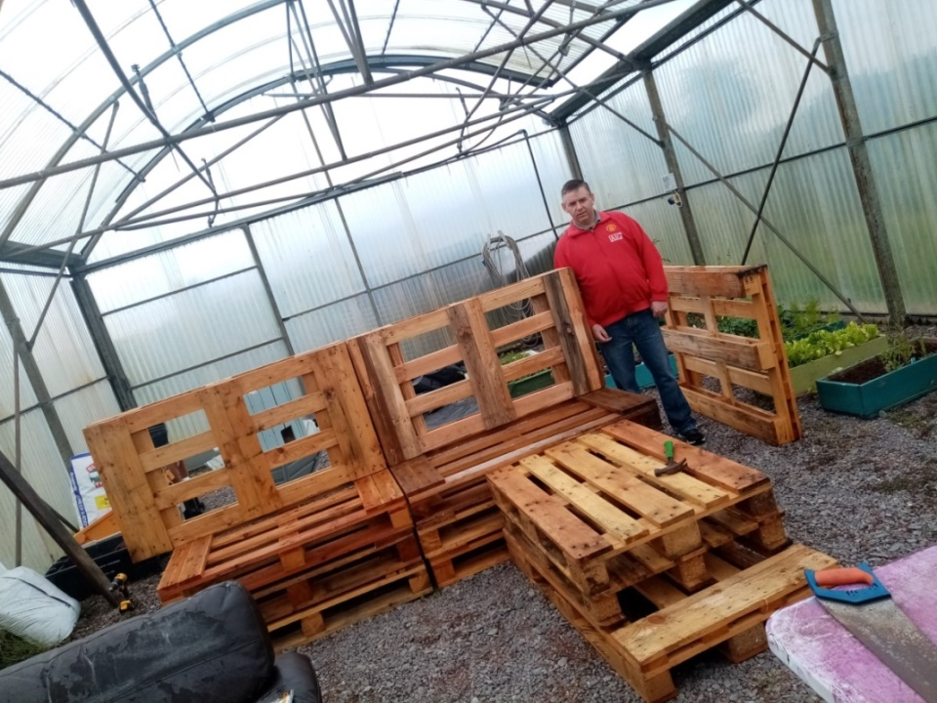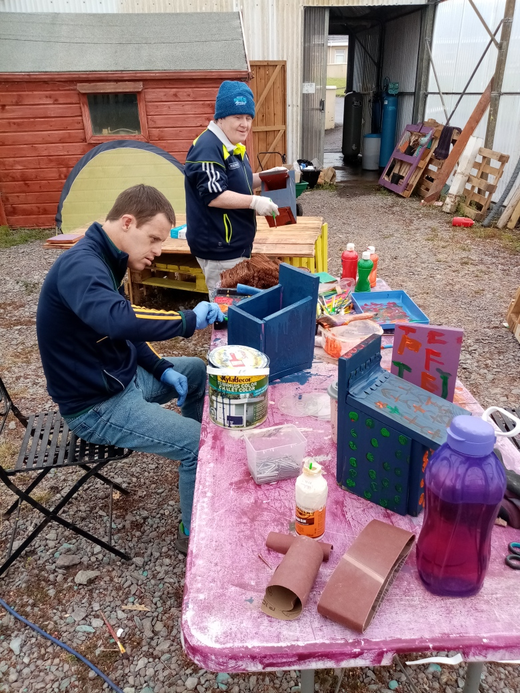

**August** or Lúnasa is the eighth month of the year and the first month of autumn. Lúnasa takes its name from the Celtic God Lú, one of the chiefs of the Tuatha Dé Dannan. The 1st of August was the end of the growing season and was called Lammas Day, the first day of harvest. Many fairs and festivals survive from that period including the Lammas Fair in Ballycastle, Co. Antrim which is held over the last Monday and Tuesday of August. August is also the month of course of Puck Fair, usually held in Killorglin on the 10th, 11th and 12th of August and Kenmare Fair on the 15th of August. Below we see preparations in the Square on the opening day of Puck Fair 2016.

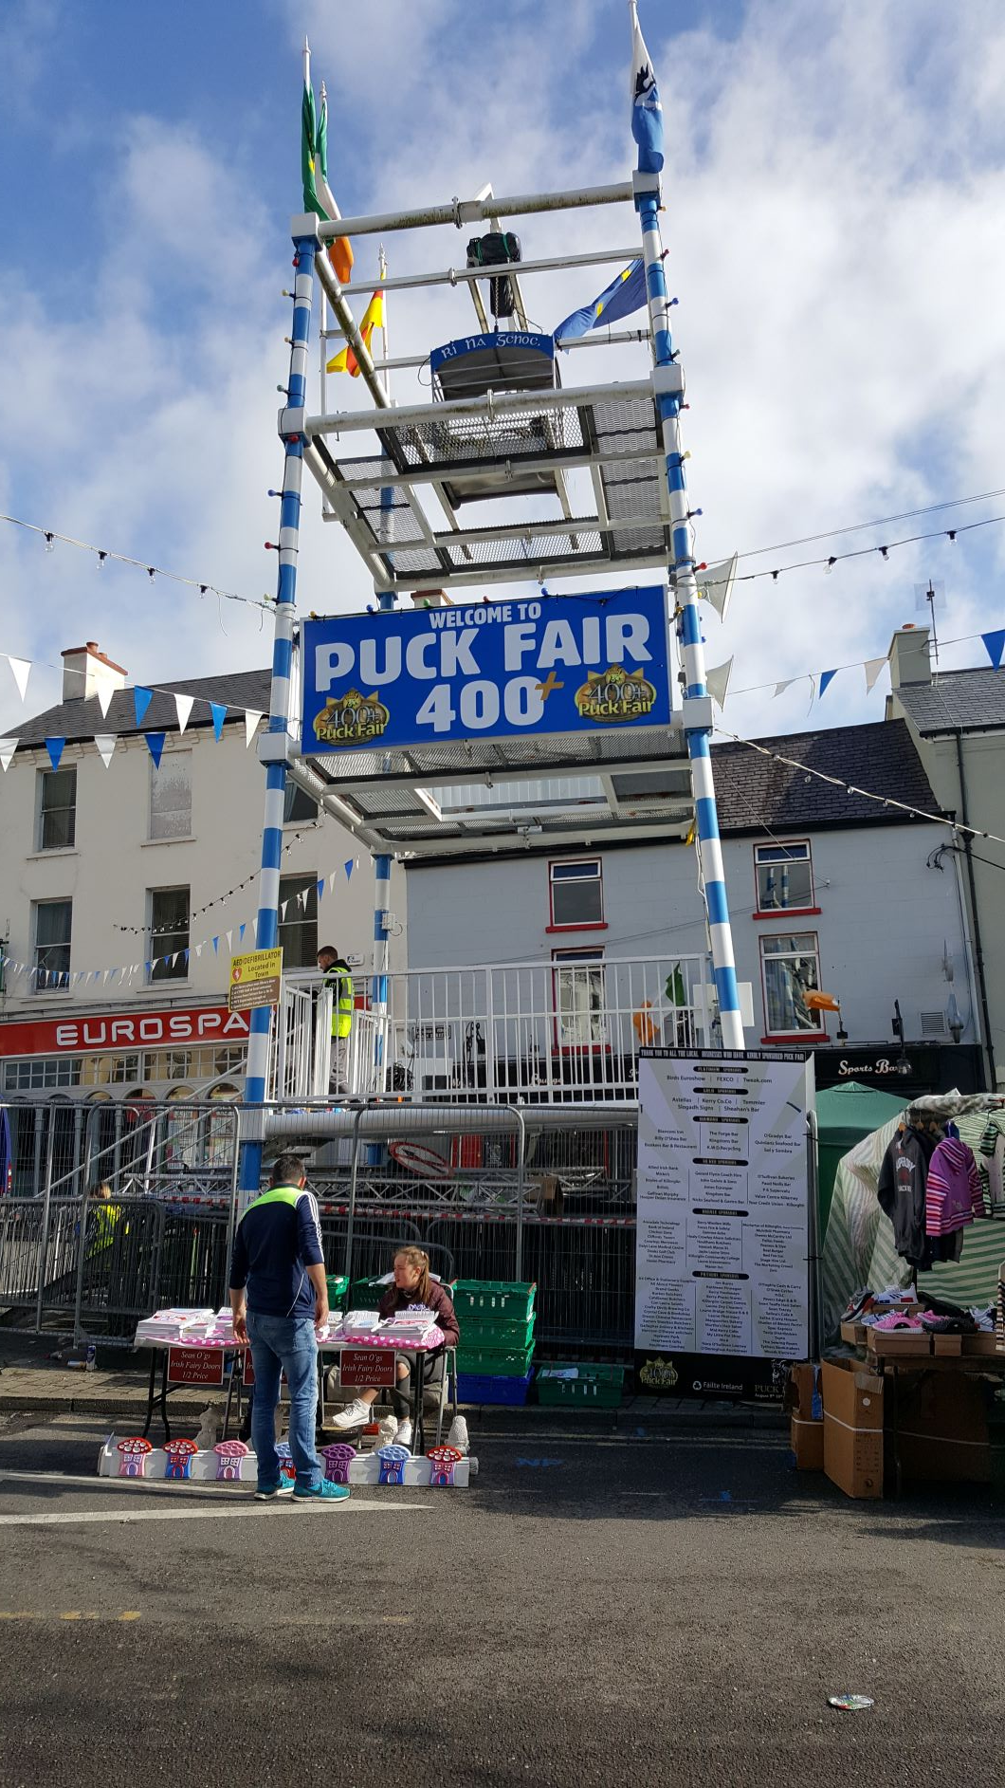If you’d like to write or share something in our Newsletter, you can contact our facilitators Rena, [renablake@newkd.ie](mailto:renablake@newkd.ie) Evelyn, [eoconnell@skdp.net](mailto:eoconnell@skdp.net) and Julie our administrator [jbrosnan@skdp.net](mailto:jbrosnan@skdp.net) .

Visit our website [www.kerrysocialfarming.ie](http://www.kerrysocialfarming.ie), follow us on Twitter @KerrySocialFarm or find us on Facebook!